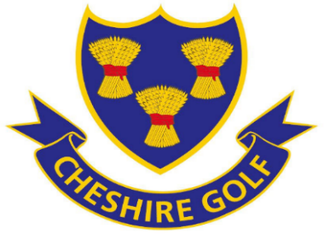
Ladies Scratch League entry form 2026

Golf Club:
Organiser:
Email:
Telephone:
Back up contact, this person will not be included in emails and results.
Back up mobile/email.

Please read the rules and pay the entry fee of £10 by BACS payment to:

The Cheshire Union of Golf Clubs
Account: 62535866 Sort Code: 40-17-14
IMPORTANT Ref: Club name followed by ‘ SL’
Or ‘SL and EW’ if paying for both competitions

In case of any queries please contact:
Kim Harcombe Mobile: 07742499476 email: kharcombe.sl_ew@yahoo.com

